Ideation Phase
Brainstorm & Idea Prioritization Template

Date | 09 February 2026
Team ID | LTVIP2026TMIDS86901
Project Name | ToyCraft Tales: Tableau's Vision into Toy Manufacturer Data
Maximum Marks | 4 Marks

Step-1: Team Gathering, Collaboration and Select the Problem Statements
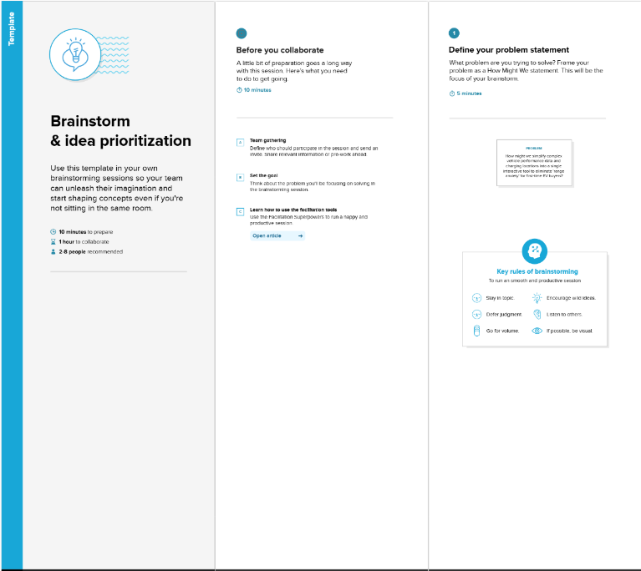
Step-2: Brainstorm, Idea Listing and Grouping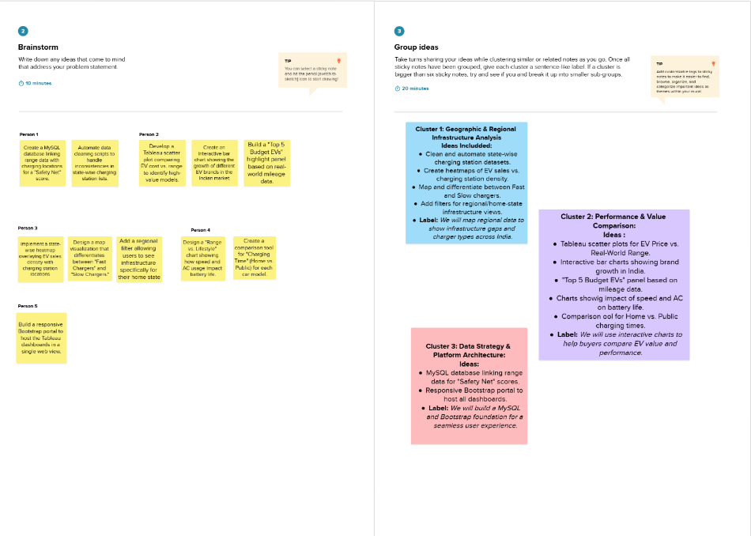
Step-3: Idea Prioritization
